

MArket segmentation of electric vehicles in india

By APURVA SATAM



July 15, 2023

FEYNN LABS

In this project, I’ve used **K Means Algorithm.**

K-Means Clustering is an [Unsupervised Learning algorithm](https://www.javatpoint.com/unsupervised-machine-learning), which groups the unlabelled dataset into different clusters. Here K defines the number of predefined clusters that need to be created in the process, as if K=2, there will be two clusters, and for K=3, there will be three clusters, and so on.

**“It is an iterative algorithm that divides the unlabelled dataset into k different clusters in such a way that each dataset belongs only one group that has similar properties.”**

It allows us to cluster the data into different groups and a convenient way to discover the categories of groups in the unlabelled dataset on its own without the need for any training.

It is a centroid-based algorithm, where each cluster is associated with a centroid. The main aim of this algorithm is to minimize the sum of distances between the data point and their corresponding clusters.

**In this project I’ve considered the k value as 4 that means there will be four clusters. Refer the below figure.**

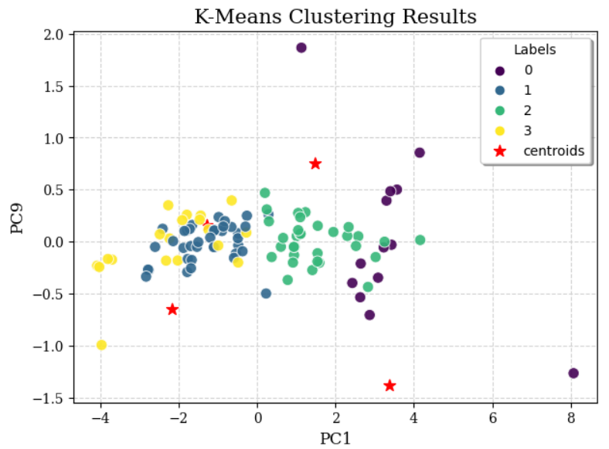

Following are the insights gained from the research work:

* Maharashtra, Gujarat, Tamandu, Karnataka and Andhra Pradesh are among the top states with the majority of EV 2-wheelers while Assam, Himachal Pradesh, Sikkim, J&K with the least.
* Uttar Pradesh, Assam and Bihar are among the top states with the majority of EV 3-wheelers while the remaining states don't seem to depend on the same.
* Maharashtra, Delhi, Karnataka, Kerala and Andhra Pradesh are among the top states with the majority of EV 4-wheelers while the remaining states have a smaller number of EV 4-wheelers.
* Maharashtra, Gujarat, Karnataka, Kerala, Uttar Pradesh, Rajasthan, and Andhra Pradesh are among the top states with the majority of EV charging stations sanctioned while the remaining states have a smaller number of the same.
* Tesla, Audi, Volkswagen, Nissan, Skoda tops the list of EVs with the maximum number of models in the Indian automobile market.
* SUV and Hatchback body types form the majority while Station and MPV the minority.
* B and C body segments form the majority while S and A the minority.
* EVs with 5 sitters dominate the market while EVs with 2 sitters are less in number.
* Based on the number of seats, Tesla, Mercedes and Nissan have the maximum number of seats and smart the minimum.
* EVs with plus type of 'Type 2 CCS' seem to dominate the market.
* Based on acceleration, EVs from Renault, Seat and Smart are the top performers while Tesla, Lucid and Porsche don’t make it to the same.
* Based on speed parameter, EVs from Tesla, Lucid and Porsche are the top performers while Renault, Smart and SEAT don’t make it to the same.
* Based on range (Km), Lucid, Lightyear and Tesla have the highest range and smart the lowest.

We can improve upon the Market Segmentation Project by having additional features such as Year of the EV Model. So that we can predict which model would survive in the upcoming years or in the long run based on their present upgrades happening every year.

I would like to try other ML Algorithms such as KNN, Random Forest, Decision Tree, etc

The estimated Market Size for the Market Domain (non-segmented) in Numbers can be around 80-100.

Price, Brand, Speed & Range could be the top 4 Variables/features which can be used to create most optimal Market Segments for the Market Domain.

**GitHub Link of Project:**

<https://github.com/apurvasatam/EV-Market-Segmentation/tree/main>